ONEWAY ACC BY WOKE
/STATISTICS DESCRIPTIVES HOMOGENEITY WELCH
/PLOT MEANS
/MISSING ANALYSIS.

Oneway

Notes
Output Created |  | 05-May-2019 23:46:16
Comments
Input | Active Dataset | DataSet0
Input | Filter | <none>
Input | Weight | <none>
Input | Split File | <none>
Input | N of Rows in Working Data File | 30
Missing Value Handling | Definition of Missing | User-defined missing values are treated as missing.
Missing Value Handling | Cases Used | Statistics for each analysis are based on cases with no missing data for any variable in the analysis.
Syntax |  | ONEWAY ACC BY WOKE  /STATISTICS DESCRIPTIVES HOMOGENEITY WELCH  /PLOT MEANS  /MISSING ANALYSIS.
Resources | Processor Time | 00 00:00:00.157
Resources | Elapsed Time | 00 00:00:00.165

[DataSet0]

Descriptives
 | N | Mean | Std. Deviation | Std. Error
Between 1-4 hours | 5 | 76.6000 | 13.31540 | 5.95483
Between 4-6 hours | 9 | 108.2222 | 28.60847 | 9.53616
Between than 6-8 hours | 3 | 72.0000 | 14.10674 | 8.14453
More than 8 hours | 13 | 97.8462 | 23.10067 | 6.40697
Total | 30 | 94.8333 | 25.60722 | 4.67522

Descriptives
 | 95% Confidence Interval for Mean |  | Minimum | Maximum
 | Lower Bound | Upper Bound | Minimum | Maximum
Between 1-4 hours | 60.0667 | 93.1333 | 67.00 | 100.00
Between 4-6 hours | 86.2318 | 130.2126 | 63.00 | 150.00
Between than 6-8 hours | 36.9569 | 107.0431 | 57.00 | 85.00
More than 8 hours | 83.8866 | 111.8057 | 50.00 | 123.00
Total | 85.2714 | 104.3952 | 50.00 | 150.00

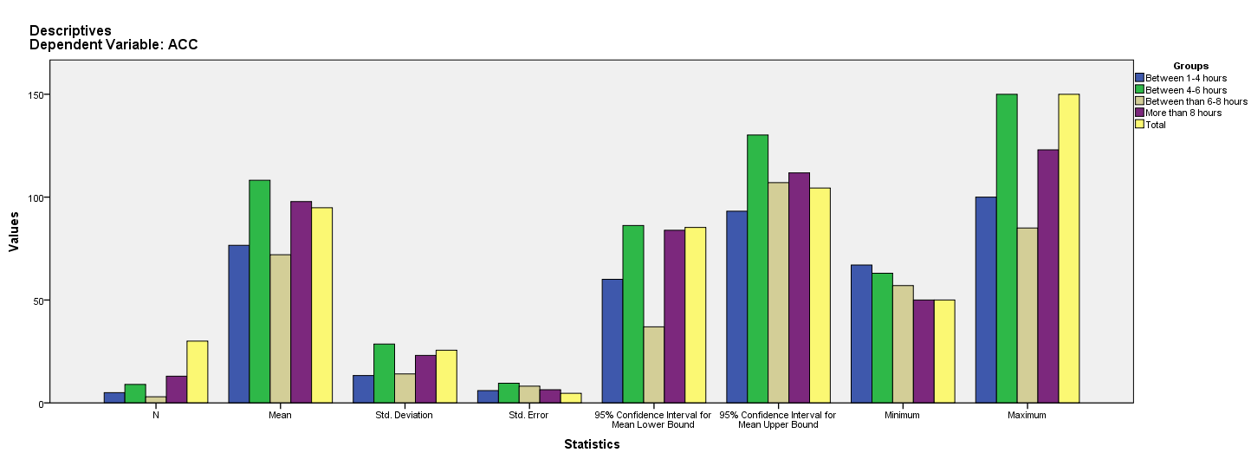

Test of Homogeneity of Variances
ACC
Levene Statistic | df1 | df2 | Sig.
2.809 | 3 | 26 | .059

ANOVA
ACC
 | Sum of Squares | df | Mean Square | F | Sig.
Between Groups | 4957.719 | 3 | 1652.573 | 3.056 | .046
Within Groups | 14058.448 | 26 | 540.710
Total | 19016.167 | 29

Robust Tests of Equality of Means
ACC
 | Statisticª | df1 | df2 | Sig.
Welch | 4.133 | 3 | 8.902 | .043
a. Asymptotically F distributed.

Means Plots

